Smart Home Designing for Melbourne Builder Inc.

Introduction

This is the technical report of smart home designing for Melbourne Builder Inc.(MBI), which is written by our consultant from HiWiFi Solutions. In this report, we will provide a few options for smart home designing alongside with some reasonable comparison that explains how to choose various plans for different customers.

Smart Home Devices
Nowadays, it is a new trend for people who follow fashion to decorate their houses by adding intelligent devices. Thus, we design some smart home plans for customers to choose for their own good.
Here is the options table.
 | Smart lighting system | Smart locks | Smart washing machines | Robotic vacuum cleaner | Smart TV and home entertainment | Smart heating
Basic | √ | √ |  |  |  | √
Mid-tier | √ | √ | √ | √ |  | √
Luxury | √ | √ | √ | √ | √ | √

We will help you find which plan is most suitable for you by discussing the advantages and disadvantages for each item.

Smart lighting system
Smart lighting is a technology that will automatically control your lighting system. It is very sufficient for energy saving since the system will decide it for you which level of the brightness you should choose for a specific situation. The main technique used by smart lighting includes daylight sensing combined with ultrasonic. The ultrasonic technique is sensitive to catch any movement, and the daylight sensing can be used to analyze the brightness of daylight. The smart lighting system will provide the best choice of brightness which can light up your house and save energy at the same time. Although, according to research, some old daylight sensing technique will also waste the energy due to switching the brightness too often (Li, Cheung, Wong, &amp; Lam, 2010).

Smart lock
The smart lock is an essential part of modern life. We offer a digital password door lock for basic plan and fingerprint door lock in mid-tier and luxury plan. The obvious advantage of the smart lock is that you do not have to remember to take your key with you. When choosing a smart lock, a technician will help you to build an electrical circuit inside your door. Both digital password lock and fingerprint lock require you to download the app and connect to the Wi-Fi to sign in your own account to change your password, or entry your fingerprint. In fact, there is a little inconvenience if your network is broken and you can’t access to your house. In that case, you can call the customer service to reset your lock. There is a set of the security processes to ensure that only the owner of the house can take this action.

Smart heating
Smart heating - also called smart thermostats - is the last item included in our basic plan. This is because heating is an important part of our life, and smart heating will make your life more comfortable. According to Champions (2018), there are three types of thermostats – manual, programmable, and smart thermostats. Like smart lighting, the smart heating system will help you control the temperature in the house for 24 hours, which can be environment friendly. The system requires a Wi-Fi connection so that it will receive the weather data and calculate the best temperature for the owner.

Smart washing machine
We will recommend mid-tier plan to the customer who wants a cleaner living environment. Thus, smart washing machine is added to this option. Smart washing machine is a Wi-Fi connected washing machine which can be controlled by using phone app. You can book a washing session on your app to set up the cleaning time so that you can save your time and energy. But if you are a person who is more accustomed with the traditional washing machine and don’t think this is essential, you can choose the basic plan.

Robotic vacuum cleaner
Another addition in mid-tier plan is robotic vacuum cleaner, which is usually called a robovac, or simply sweeping robot. The robovac can automatically plan the cleaning routine for your house by their intelligently programmed system. The robot can offer the customer, especially the people who have problem with physical movement, a true convenience to sweep and wet the floor and make the house fresh again. Most of the robovac require a Wi-Fi environment since they must upgrade themselves by connecting to the internet. It is said that one of the wonderful benefits of robovac is that it can clean the various surface with different material (Robot, 2020), which is helpful because some surface is hard to clean for people.

Smart TV and home entertainment
There will be more interesting item provided in our luxury plan, and one of them is smart TV. Distinguished from traditional TV, smart TV will bring you extremely amazing experience about entertainment. You can not only watch the latest show on Netflix, Hulu, or other TV program providers, but also connect your Nintendo, Xbox, or Play Station to smart TV. A research from Roy Morgan (2015) shows that 12.5% Australia family have smart TV in their house. Currently, lots of people are getting through the depression, anxiety, and loneliness of isolation due to COVID-19, thus, smart TV and home entertainment can light up your normal life a little more. Smart TV also requires a high-speed Wi-Fi environment since the streaming data is plenty. The disadvantage of smart TV is that your children may be too obsessed with it. Furthermore, some of the TV provider will collect the user data for improvement of their machine learning, and this might cause some privacy issue.

Wi-Fi requirements
Since most of smart home devices require a high upload/download speed for fluently receiving the data, we will recommend customers to choose a Wi-Fi network with 5 GHz brand, 80 width. Although usually the coverage of 2.4 GHz band is wider, 5 GHz can provide a faster speed. Meanwhile, if there are too many smart devices using the same Wi-Fi, it is better to use 5 GHz since it has more channels because this can reduce the interference among these devices. According to Dolinska, Jakubowski, and Masiukiewicz (2017), 5GHz band has 23 available channels and 2.4 GHz only has 3.

Conclusion
The basic option is the most affordable plan. If you just want to experience what smart home is like, you may want to choose this plan. And since basic plan do not have many devices, you will be fine to choose a 2.4 GHz network.
The mid-tier option is for people who want to have a tidy house. The items that are added will help you clean the house more efficiently. This is really a bargain.
The luxury option can give you the best experience about smart home. You will be benefited from the convenience brought by the smart devices and enjoy the entertainment from your smart TV. It is a bit expensive, but you will absolutely deserve it.

Reference
Champions, S. (2018, May 18). Manual vs Programmable vs Smart Thermostats: Which Is Best for You? Retrieved May 19, 2020, from https://www.servicechampions.net/blog/manual-vs-programmable-smart-thermostats/
Dolinska, I., Jakubowski, M., &amp; Masiukiewicz, A. (2017). Interference comparison in Wi-Fi 2.4 GHz and 5 GHz bands. 2017 International Conference on Information and Digital Technologies (IDT). doi:10.1109/dt.2017.8024280
Li, D. H., Cheung, K., Wong, S., &amp; Lam, T. N. (2010). An analysis of energy-efficient light fittings and lighting controls. Applied Energy, 87(2), 558-567. doi:10.1016/j.apenergy.2009.07.002
Robot. (2020, February 25). 10 Benefits of Owning a Robot Vacuum 2020. Retrieved May 19, 2020, from https://bestrobotvacuums2020.com/benefits-owning-robot-vacuums/
The tube meets the net: More Australians connect their televisions online. (n.d.). Retrieved May 19, 2020, from http://www.roymorgan.com/findings/6031-households-with-internet-smart-television-tbox-apple-and-chromecast-october-2014-201501160248

WLAN Design and Security

B1: Survey
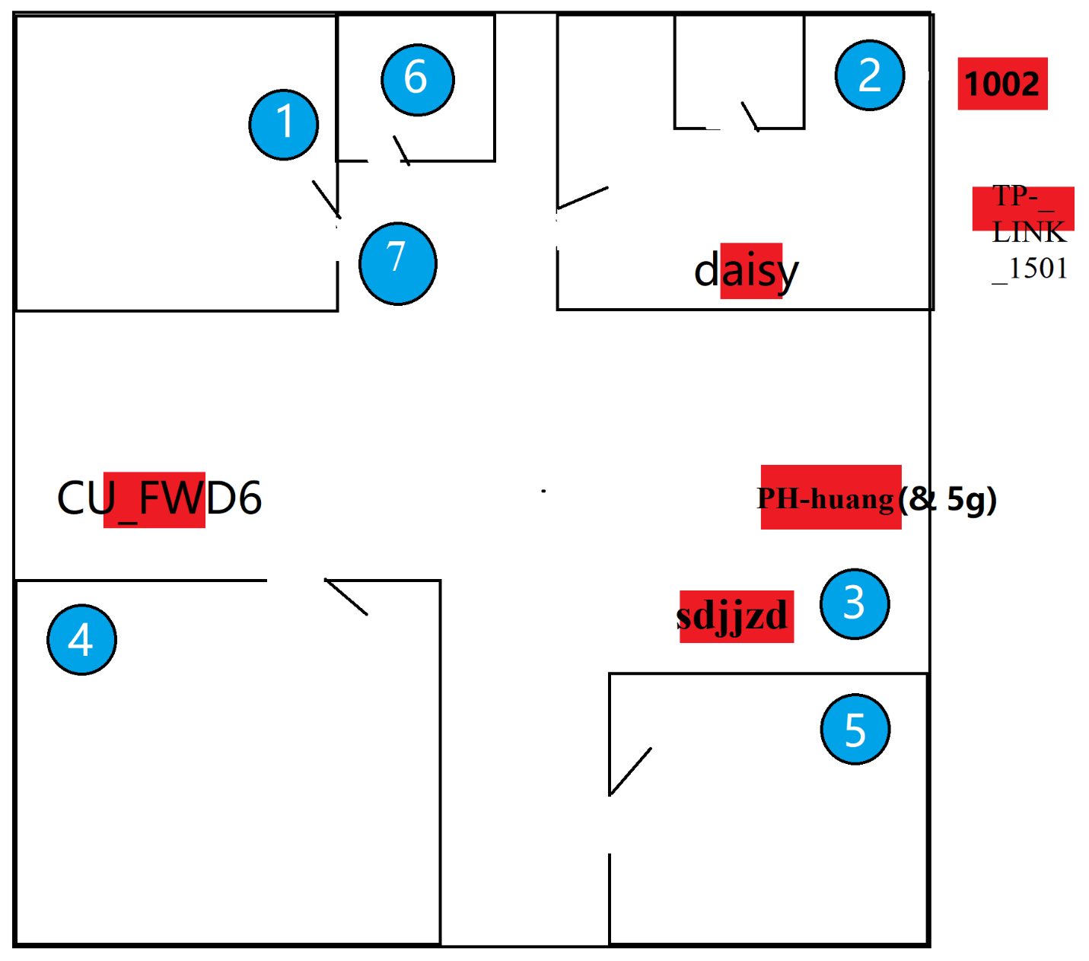
Fig. B-1
Dimension: 12m(width), 13m(length)
Blue circle: locations of measurements
Red square: APs

Location 1 Record Table
Network name | MAC address | Signal  Strength(dBm) | SNR | band | channel(s) | Width
daisy | D0:76:E7:02:4D:97 | -46 | 58 | 5 | 149 | 80
daisy | D0:76:E7:02:4D:95 | -50 | 53 | 2.4 | 11 | 40
CU_FWD6 | 6A:41:C9:E3:FE:E8 | -74 | 26 | 2.4 | 4 | 20
PH-huang | 76:7D:24:53:25:5B | -65 | 36 | 2.4 | 7 | 20

Location 2 Record Table
Network name | MAC address | Signal  strength(dBm) | SNR | band | channel(s) | Width
daisy | D0:76:E7:02:4D:97 | -40 | 67 | 5 | 149 | 80
daisy | D0:76:E7:02:4D:95 | -42 | 65 | 2.4 | 11 | 40
1002 | 8C:53:C3:96:04:BD | -77 | 22 | 2.4 | 2 | 20
TP-LINK_1501 | 8C:A6:DF:B2:64:FC | -78 | 21 | 2.4 | 11-1 | 40

Location 3 Record Table
Network name | MAC address | Signal  strength(dBm) | SNR | band | channel(s) | Width
daisy | D0:76:E7:02:4D:97 | -68 | 33 | 5 | 149 | 80
sdjjzd | FC:D7:33:D7:83:0A | -56 | 47 | 2.4 | 11-1 | 40
PH-huang | 76:7D:24:53:25:5B | -57 | 45 | 2.4 | 7 | 20
PH-huang-5G | 74:7D:24:53:25:5B | -73 | 27 | 5 | 36 | 40
TP-LINK_1501 | 8C:A6:DF:B2:64:FC | -75 | 24 | 2.4 | 11-1 | 40

Location 4 Record Table
Network name | MAC address | Signal  strength(dBm) | SNR | band | channel(s) | Width
daisy | D0:76:E7:02:4D:97 | -67 | 34 | 5 | 149 | 80
daisy | D0:76:E7:02:4D:95 | -71 | 29 | 2.4 | 11 | 40
CU_FWD6 | 6A:41:C9:E3:FE:E8 | -60 | 42 | 2.4 | 10 | 20
PH-huang | 76:7D:24:53:25:5B | -62 | 40 | 2.4 | 7 | 20

Location 5 Record Table
Network name | MAC address | Signal  strength(dBm) | SNR | band | channel(s) | Width
sdjjzd | FC:D7:33:D7:83:0A | -78 | 21 | 2.4 | 11-1 | 40
daisy | D0:76:E7:02:4D:95 | -75 | 24 | 2.4 | 11 | 40
daisy | D0:76:E7:02:4D:97 | -86 | 12 | 5 | 149 | 80
PH-huang | 76:7D:24:53:25:5B | -66 | 35 | 2.4 | 7 | 20

Location 6 Record Table
Network name | MAC address | Signal  strength(dBm) | SNR | band | channel(s) | Width
daisy | D0:76:E7:02:4D:97 | -70 | 30 | 5 | 149 | 80
daisy | D0:76:E7:02:4D:95 | -78 | 21 | 2.4 | 11 | 40
PH-huang | 76:7D:24:53:25:5B | -76 | 23 | 2.4 | 7 | 20

Location 7 Record Table
Network name | MAC address | Signal  Strength(dBm) | SNR | band | channel(s) | Width
daisy | D0:76:E7:02:4D:97 | -42 | 63 | 5 | 149 | 80
daisy | D0:76:E7:02:4D:95 | -49 | 56 | 2.4 | 11 | 40
CU_FWD6 | 6A:41:C9:E3:FE:E8 | -76 | 14 | 2.4 | 4 | 20
PH-huang | 76:7D:24:53:25:5B | -65 | 36 | 2.4 | 7 | 20

B2: Report
This report will analyse the data collected from the observation from above.
Most access points are competing on different channels, while some are not. For example, “sdjjzd” shares the same channel 11-1 with “TP-LINK_1501”. They will use overlap channels. To improve this overlapping problem, one of them could use 5 GHZ band since there is more non-overlapping channels in 5 GHZ band. (“Designing a Dual-Band Wireless Network | MetaGeek,” 2020) .
The signal strength of “daisy”(5 GHZ band) in location 3 is -68 dBm and in location 5 is -75 dBm. This is because the access point is in the same room with location 2, and there is a wall between 3 and 5, which deduce the signal strength. The signal strength of “daisy” ”(5 GHZ band) in location 1 and 7 is slightly different because of the wooden door. This attenuation is less than the effect of wall. Meanwhile, “sdjjzd” deduces from -56 to -78. The attenuation is greater than “daisy” (5 GHZ band), so it can be assumed that 5 GHZ band AP is more stable than 2.4 GHZ band.
According to the research, a good signal strength should range from -30 dBm to -80 dBm (“Best dBm Values for Wifi,” 2016). Since the home Wi-Fi “daisy” range from -40 dBm to -78 dBm, the desired area is covered well. I think the placement can be improved a little bit since the home Wi-Fi is not located in the centre of the house. So, it is more suitable to place the Wi-Fi in the living room(in the middle) rather than bedroom.
The attenuation caused by human body is obvious. The signal strength of access point “daisy” reduces from -44 dBm to -60 dBm after a human who is holding the laptop turning around. According to a research, human body can cause a signal attenuation, and this can be improved by using an orientation-independent model (Fet, Handte, & Marrón, 2013, p. 504).

[This report contains 325 words.]

Reference
Best dBm Values for Wifi. (2016). Retrieved from https://support.randomsolutions.nl/827069-Best-dBm-Values-for-Wifi
Designing a Dual-Band Wireless Network | MetaGeek. (2020). Retrieved from https://www.metageek.com/training/resources/design-dual-band-wifi.html
Fet, N., Handte, M., & Marrón, P. J. (2013). A model for WLAN signal attenuation of the human body. Proceedings of the 2013 ACM International Joint Conference on Pervasive and Ubiquitous Computing - UbiComp ’13, 499–508. https://doi.org/10.1145/2493432.2493459

